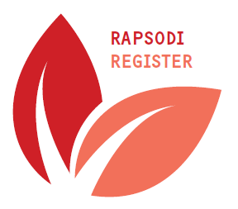
Proposal for research using patient data from RAPSODI (Registry of Adult Patients with Severe asthma for Optimal Disease management)

Name applicant

Institution

Address

E-mail

Telephone

Title of proposal

Summary
(250 words)

Relevance
(100 words)

Questions

Hypotheses

Design

Analyses | Liefst in de vorm van (lege) data-tabel

